***NAME: Sitara Rehman***

***Sap: 66454 Bscs***

***Subject: Operating system Lab 04***

***Submitted to : Ma’am Ayesha Akram***

***Semester: 05***

***Task01***

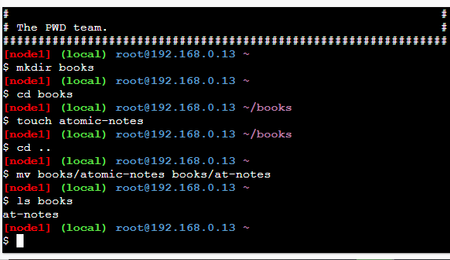

***Task02***

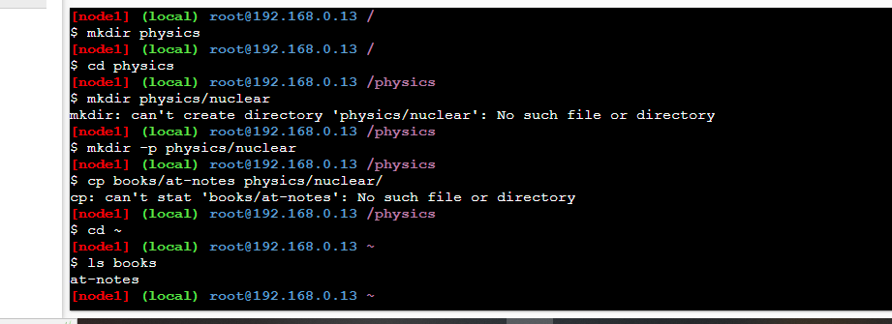

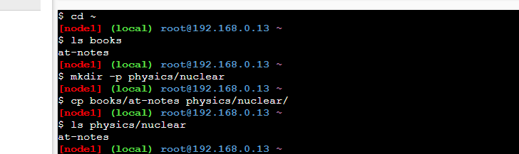

***Task:03***

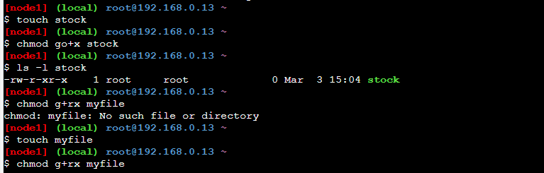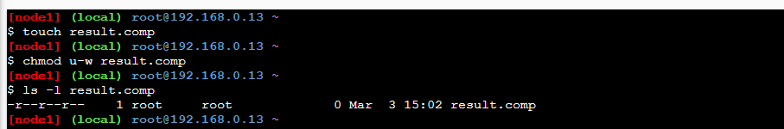

***Task:04***



